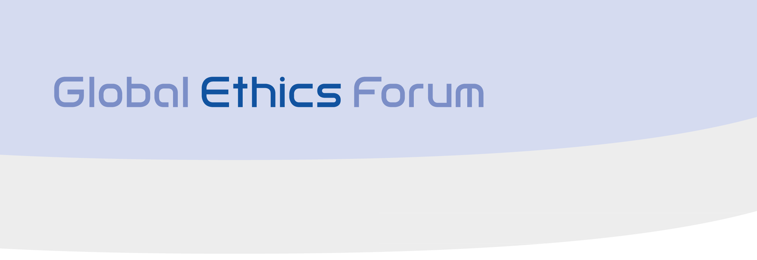

a project of

Equal in an Unequal World:

The Value of Values in Responsible Business

Global Conference, 3-5 January 2014, Indian Institute of Management Bangalore

Programme – updated 22 October 2013

Day One | Theme |  | Speakers
09:00-09:20 | Opening Ceremony |  | Devanath Tirupati, Director, Indian Institute of Management Bangalore  Walter Fust, President Globethics.net
09:20-09:45 | Keynote Address  Equal in an Unequal World - What are the current and future dimensions of inequality on national and global levels, and how are they interrelated with the various aspects of sustainable development? |  | Sachin Plot, Minister of Corporate Affairs, India (invited)
09:45-11:00 | Panel discussion  Equal in an Unequal World  Perspectives from business, international organisations and environmental agencies |  | S.D. Shibulal CEO and Co-founder, Infosys, India  Ratan Tata, Chairman Emeritus, Tata Sons/Tata Trusts, India (invited)  Mervyn King, Chair IIRC, South Africa/Global  Jayati Ghosh, professor, Jawaharlal Nehru University, India  Bao Ziran, Senior expert, Center for Environmental Education and Communications of Ministry of Environment and Protection, China
11:00-11:30 | Networking break
11:30-12.45 | Panel discussion  Equality and Diversity in Business Relations BRICS-Africa: How much equality and how much inequality? The Value of Values – What are the mechanisms for minimising inequality? What is the role of ethics in business, public sector, NGOs, academic research in BRICS countries? |  | Liu Baocheng, Director, Center for International Business Ethics, UIBE, China  Deon Rossouw, Ethics Institute of South Africa, South Africa  Kumud Srinivasan, President, Intel India  Aurélien Atidegla, Dynamique OSCAF, Africa  Alexander Ageev, Director, Institute for Economic Strategies, Russia;  Klaus Leisinger, Novartis Foundation for Sustainable Development, Switzerland
12:45-13:00 | Presentation of Globethics.net “My Choice for Equality” campaign |  | Video made and presented by members of youth leadership initiatives and other participants in the campaign
13:00-14:00 | Lunch
14:00-15:30 | Tackling the Economic Dimension of Inequality – challenges, opportunities, and way forward  Workgroup sessions - four parallel workgroups with one chairperson and one rapporteur per group
 | W1: Gender equality |  | Priya Rajeev, research gender ethics, Chennai, India  Paranjoy Guha Thakurta, investigative journalist, India  Le Ping, Deputy director, Research Institute of Globalization and China's Modernization, UIBE, China  Afua B Ansre, UN Women Africa
 | W2: The role of financial markets for equality |  | Raghu Raman, Financial Advisor to PM, India (invited)  Representative, African Development Bank (invited)  Maximilian Martin, Director, Impact Economy, Switzerland(invited)
 | W3: Sharing economy: Cooperatives, social enterprises, anarchic enterprises, microfinance |  | Patrick Nickisch, Jain Institute for Relative Economics, Ladnun  Sudha Reddy, Right and Responsibility Collective, India/Nepal  P D Jose, IIMB, India: sharing economy  Zheng Zhihai, Former president, researcher, Chinese Academy of International Trade and Economic Cooperation (CAITEC) of MOFCOM  Arnold Smit, BEN Africa
 | W4: Transparency in religious organisations and NGOs |  | Jacob Belly, the Pastors Association, Church of South India  Fredrik Galtung, Integrity Action, UK/Global  Samuel Kobia, Africa, Special Envoy South Sudan, World Council of Churches
15:30-16:00 | Networking break
16:00-17:30 | Good Practices Corporate Cases 4-6 parallel Q&A sessions - live interviews with a panel of sponsoring companies and SMEs.
18:00-20:00 | Cultural programme and cocktail  Video address HH Sri Sri Ravi Shankar, Art of Living  Messages from Africa, Asia, Europe and the Americas
Day Two | Theme | Speaker
09:00-10:30 | Tackling the Social, Environmental and Spiritual Dimension of Inequality – challenges, opportunities, and way forward  Workgroup sessions - four parallel workgroups with one chairperson and one rapporteur per group
 | W5 Equal access to natural resources  Perspectives from India, Africa, China | Sunita Narain, New Delhi-based Centre for Science and Environment (invited)  Nnimmo Bassey, Executive Director, Environmental Rights Action/Friends of the Earth Nigeria (invited)  Nigussu Legesse, Programme Executive Regional Relations Africa, WCC  Liu Dexi, Professor, Institute for international studies party school of the central committee of the communist party of China (IISS CCPS), China  Yin Shoupeng, Chairman, Beijing Jiahewuxian Science & Technology Co., LTD, China
 | W6 Holistic business education to overcome inequality | Anders Aspling, Globally Responsible Leadership Initiative GRLI, Belgium/Global  Vasanthi Srinivasan, IIMB  Deon Rossouw, Ethics Institute of South Africa, South Africa  Shu Wen, Director, Future Leadership Department, Student CSR Association, UIBE, China
 | W7 Spirituality for sustainability | Sanju Mukkerji, IIM Shillong, India (Hindu)  Cui Wantian, Shenyang/China (Christian)  Evgeni Morozov, referent to His Holiness Patriarch of Moscow and All Russia Kirill, Russia (Orthodox Christian)  Parichart Suwanbubbha, Institute of Human Rights and Peace Studies, Mahidol, Thailand (Buddhist)
 | W8 Innovation ethics: innovation for and with the marginalised and for sustainability | Herman Hesse, entrepreneur, Ghana  Christoph Stuekelberger, Globethics.net  Tian Yike, EMBA Advisor, Peking University, China  Ganesh Natan, Professor Innovation Ethics, Switzerland  Representative, innovation laboratory, Bangalore
10:30-11:00 | Networking break
11:00-12:30 | How can equality be improved – practical tools and cross-sector collaboration  Workgroup sessions - four parallel workgroups with one chairperson and one rapporteur per group
 | W9 Ethical principles of equality and inequality | Gita Sen, expert gender& development,professor at IIMB, India (invited)  Heidi Hadsell, Hartford Seminary, USA  Saju Chackalakam, President of DVK and Professor of Philosophy, India  Representatives, private and business sector
 | W10 2% for CSR in India: private-public-NGO-partnerships | Representative, Ministry/Indian Institute of Corporate Affairs  Representative, Guidestar, India  Private Sector: WIPRO Foundation  Tayfun Zaman, Ethics Business Association, Turkey  Fan Libo, Dean, School of International Business, UIBE, China  Muhammad Machasin, Government Representative, Indonesia
 | W11 SME sustainable leadership across continents | Teodorina Lessidrenska, Globethics.net  Jörg Börgi, KMU nachhaltig GmbH, Switzerland  Guido Sacco, SME owner, Switzerland  Yahya Wijaya, Indonesia (invited)  Rockson Dogbegah, Ghana (invited)
 | W12 Social media for participation and equal access to information | Representative, WACC, Asia, citizen journalism  Diana Joseph, Director, Forth Wave Foundation, India  Zhao Yang, Hostess, China Radio International  Walter Fust, President Globethics.net, UN Broadband Commission
12:30-13:30 | Lunch
13:30-15:30 | The way forward: the global society should manage the diverse forms and dimensions of inequality on the base of preservation of the harmonious balance between human and non-human beings and the environment. | Summary of outcomes from workshops (posters, cartoons, reports)
15:30-16:00 | Networking break
16:00-17:30 | Globethics.net Principles on Equality and  Inequality for a Sustainable Economy  ‘My Choice for Equality’ campaign awards | High level closing panel: three Global Ethics Forum Co-chairs and three keynote speakers  Closure of the ‘My Choice for Equality’ campaign
Follow-up events
5-6 January | Ethics and Sustainability Training for SMEs and entrepreneurs

www.globalethicsforum.net

Organised in collaboration with
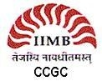

Centre for Corporate Governance and Citizenship,

Indian Institute of Management Bangalore (IIMB)


Centre for International Business Ethics (CIBE) China

